**VR Assignment**

**Bhagyaraj Mahida Enrollment ID:22000222**

**Task 1: Set Up Your Unity Project & Configure the VR Environment**

**Steps:**

1. Create a New Unity Project
2. Install XR interaction toolkit and Plugins
3. Configure XR Interaction Toolkit:
4. Add a VR Camera:
5. Configure the Player’s Hands:
6. Testing the VR Environment:

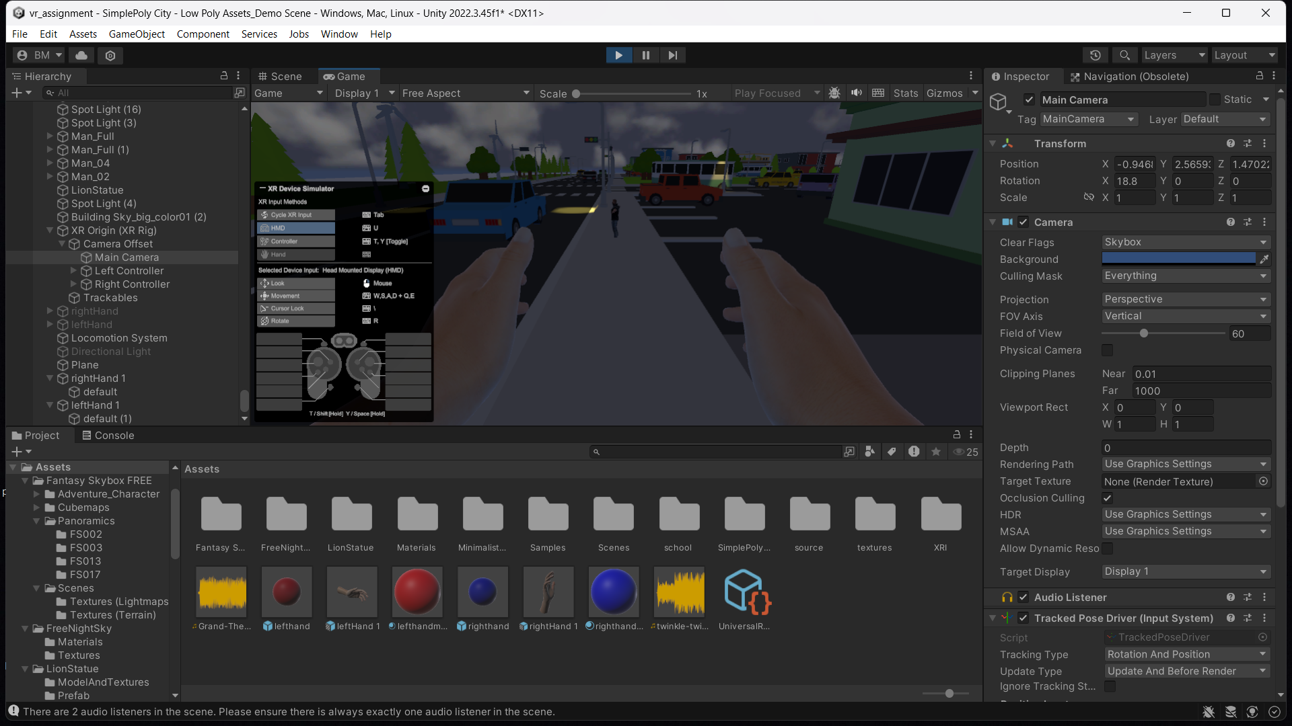

**Task 2: Create the Ground Plane**

**• Create a larger ground area so player can move around**

**• You can use Terrain object for that**

**Steps:**

1. Created a Larger Ground Area
2. I also included a city for the player to move around.
3. Used terrains to create a large, customizable ground area.
4. Also had to adjust terrain's size to cover the city and enable player movement.

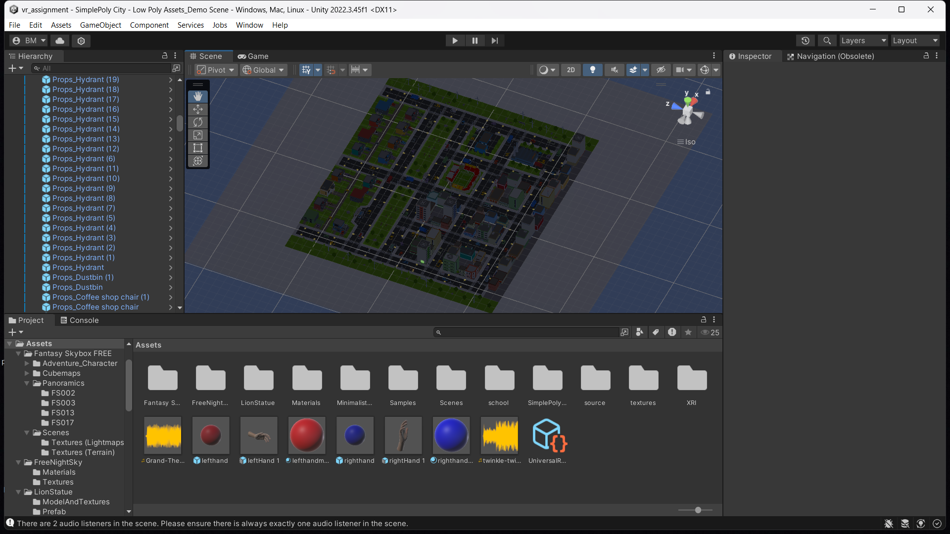

**Task 3: Add a Skybox**

**• You can use sky presets**

**• Try to make it more detailed and more interesting**

**Steps:**

1. Added a Skybox from unity asset store to enhance visual immersion.
2. Chose a dark theme skybox because i wanted to give the city some night lights.

3. Customized Skybox by applying some cloud movement in it.

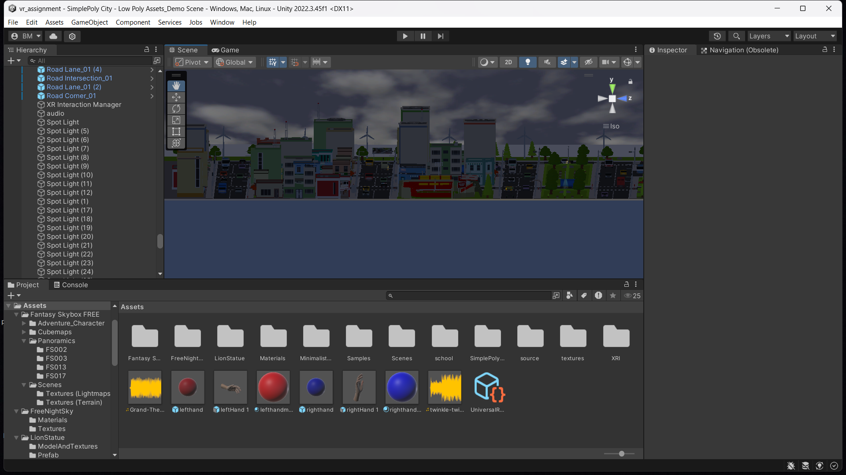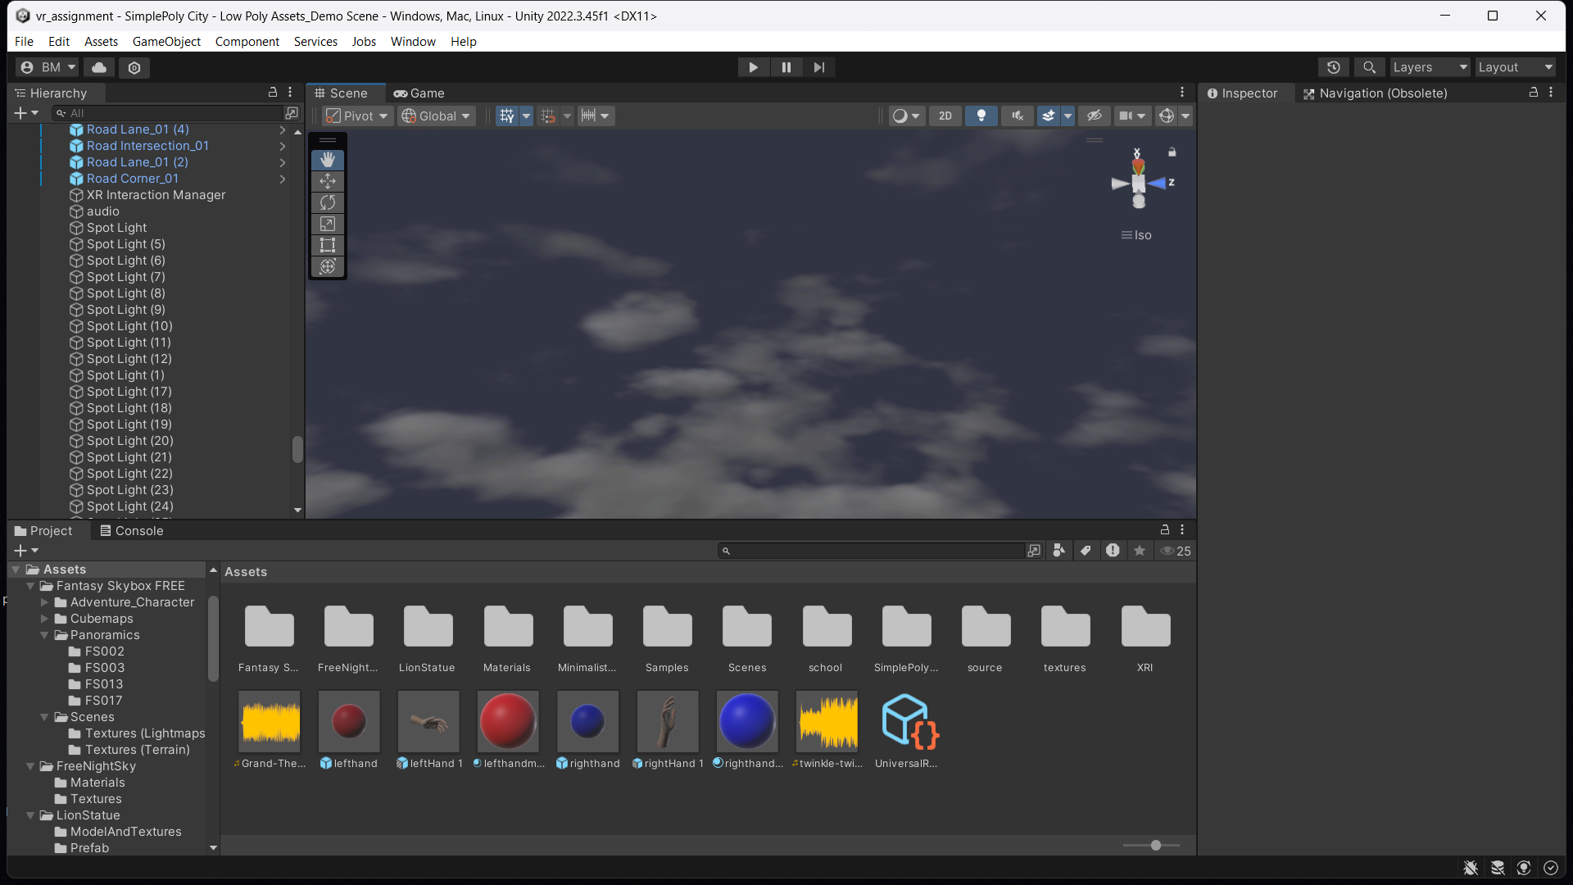

**Task 4: Add Environment Objects**

**• You can use Assets to create an engaging Environment**

**• Create a grabbable objects spawning at random locations**

**Steps:**

1. Added environment objects (trees, buildings, benches) to make the city more engaging.
2. To make the project look better, I also added street lights which can be turned on/off.

3. Created grabbable objects that spawn at random locations for interaction in the vr environment.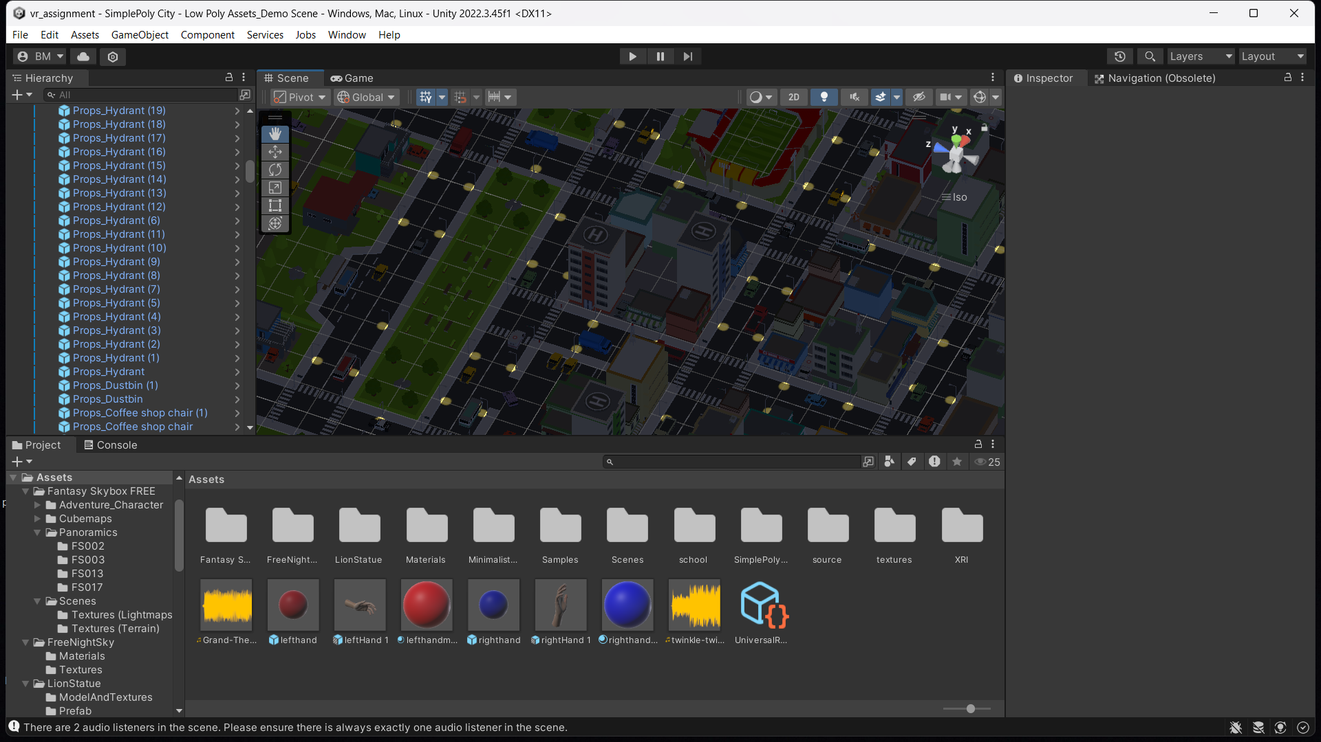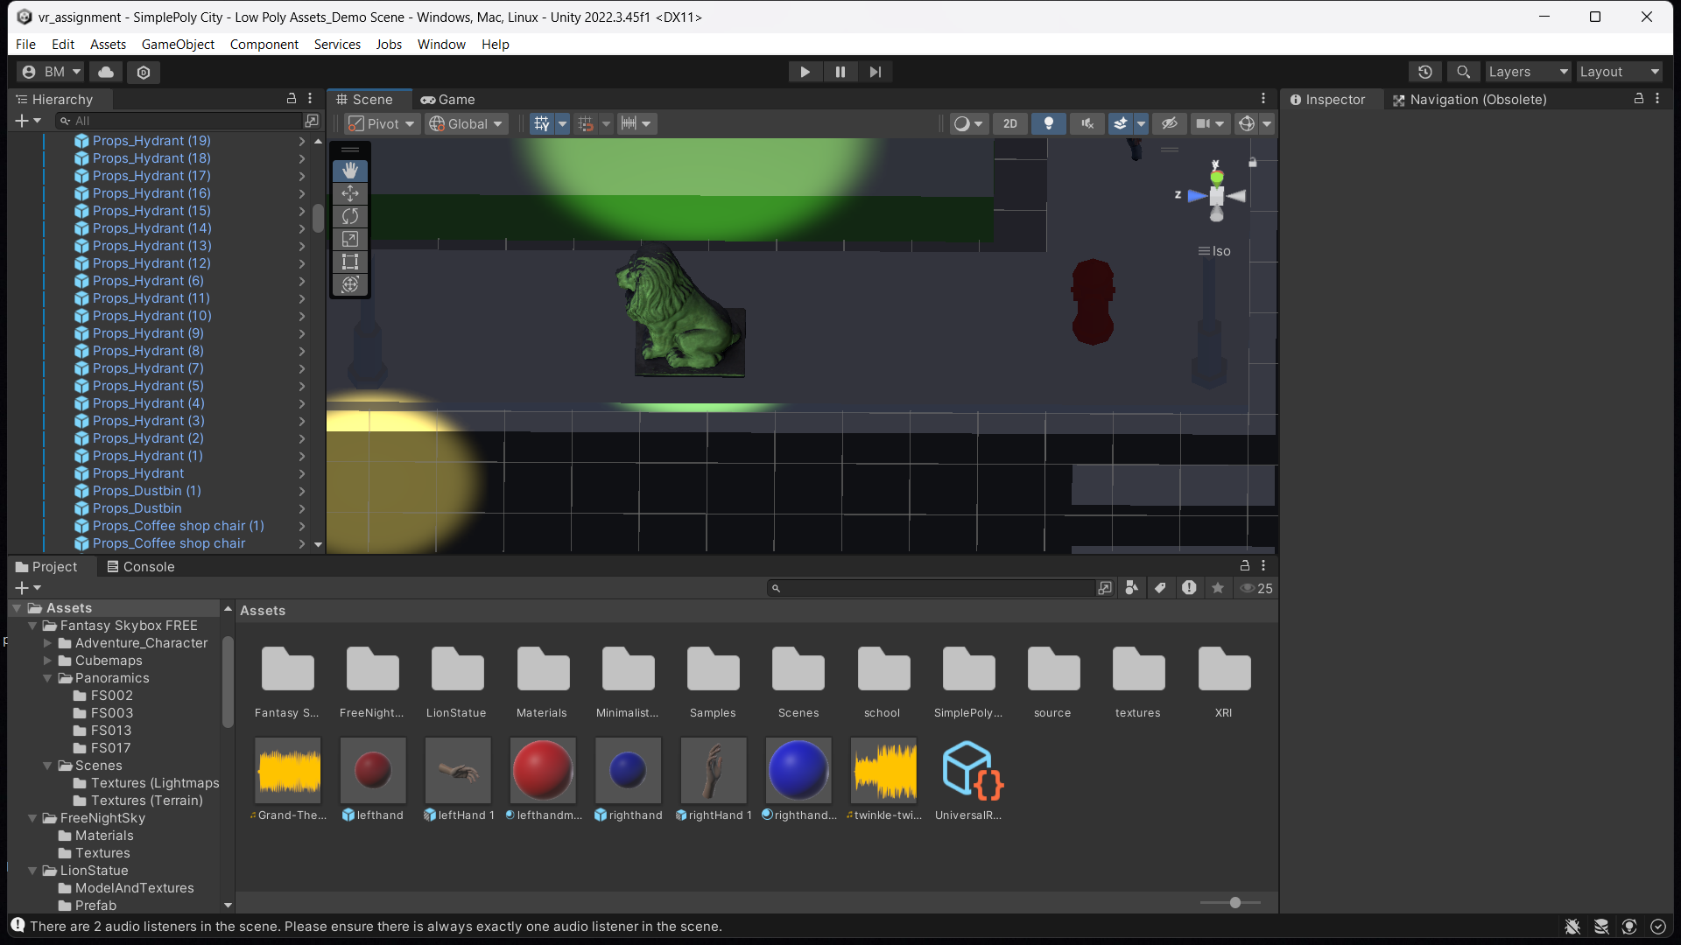

**Task 6: Configure Lighting and Shadows**

**Steps:**

1. To make the project look better, I also added street lights which can be turned on/off.
2. Also added soft shadows to all the night lights.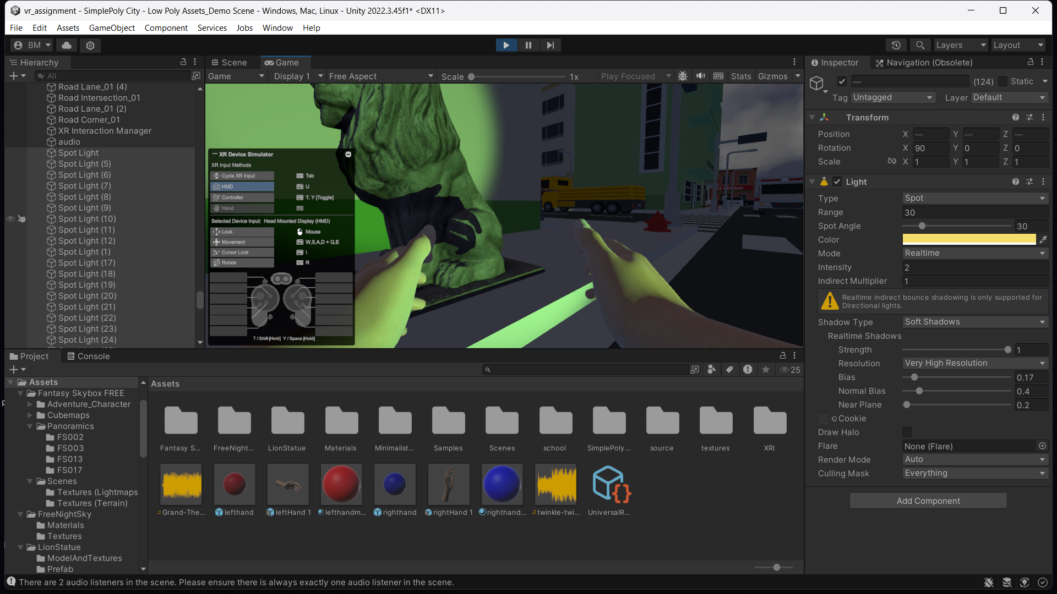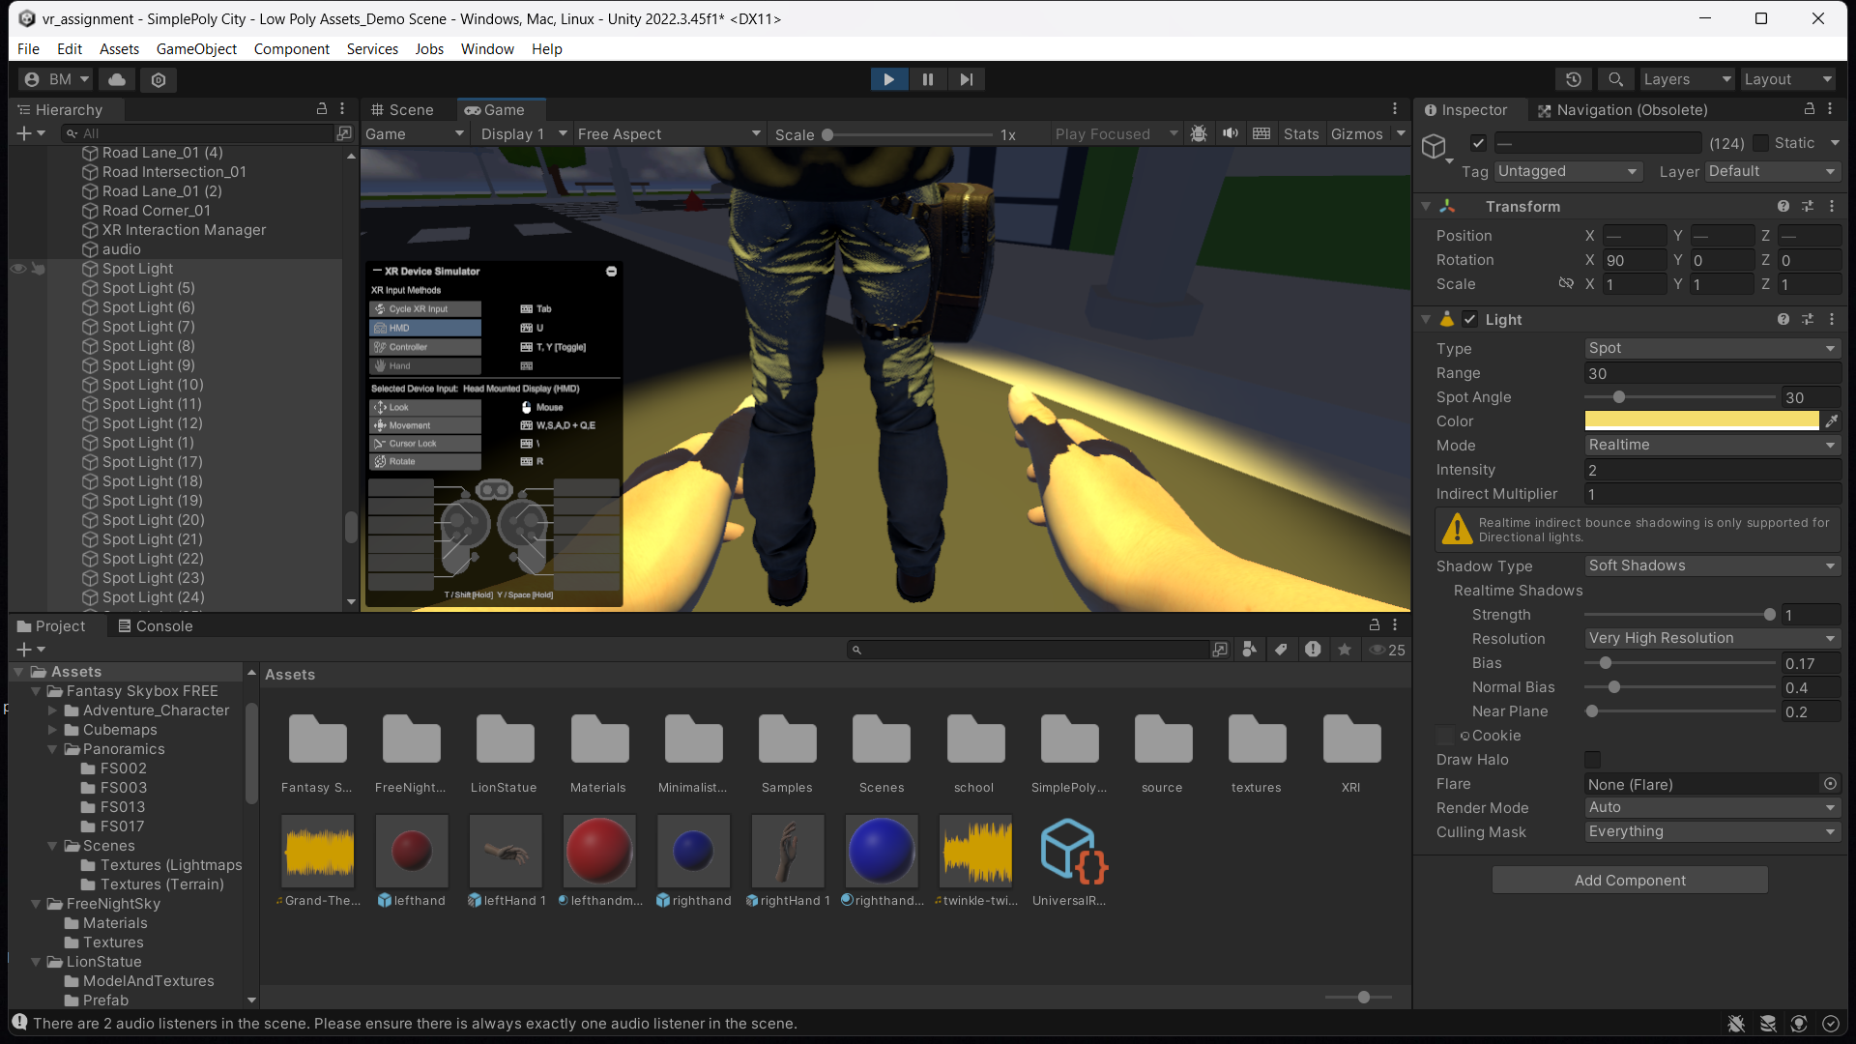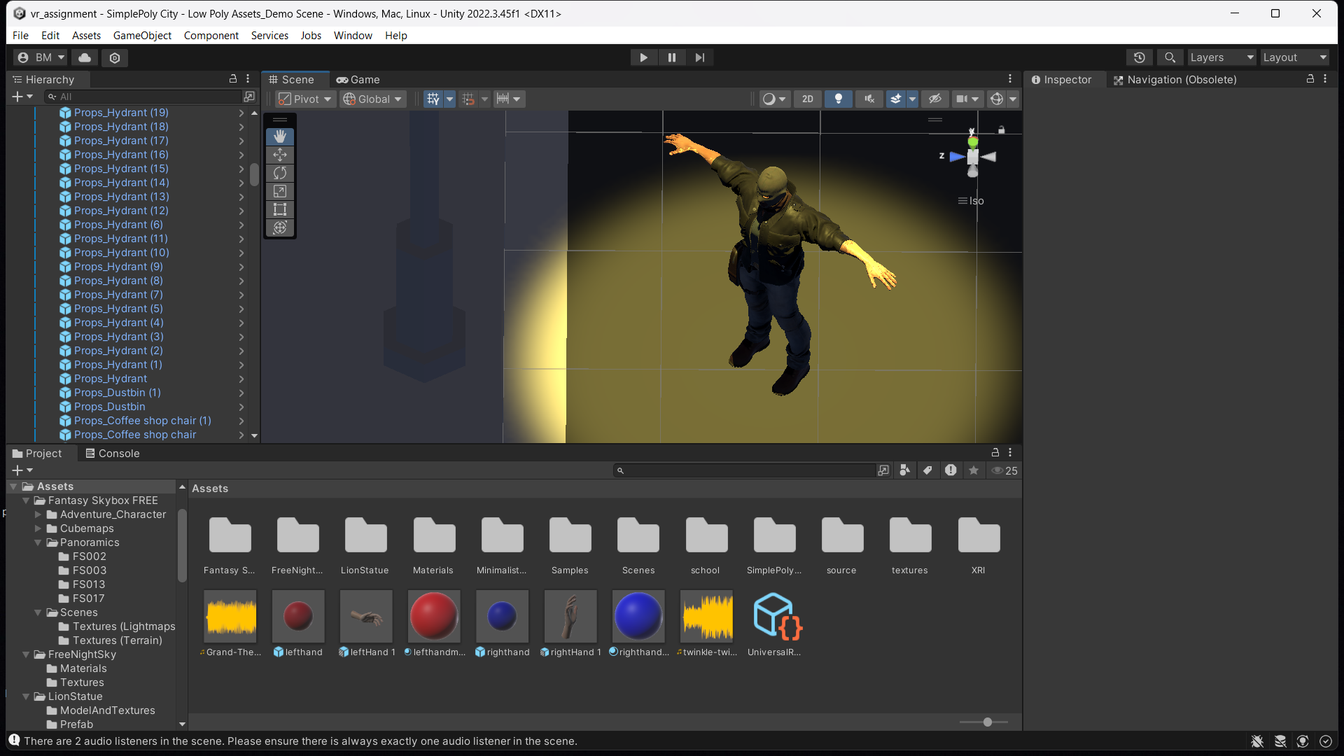

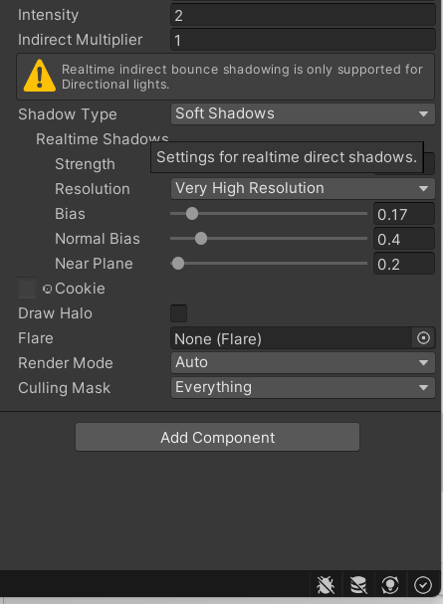

**Task 7: Add Audio**

**Steps:**

1. Imported and added background sounds of a game using Audio Source.

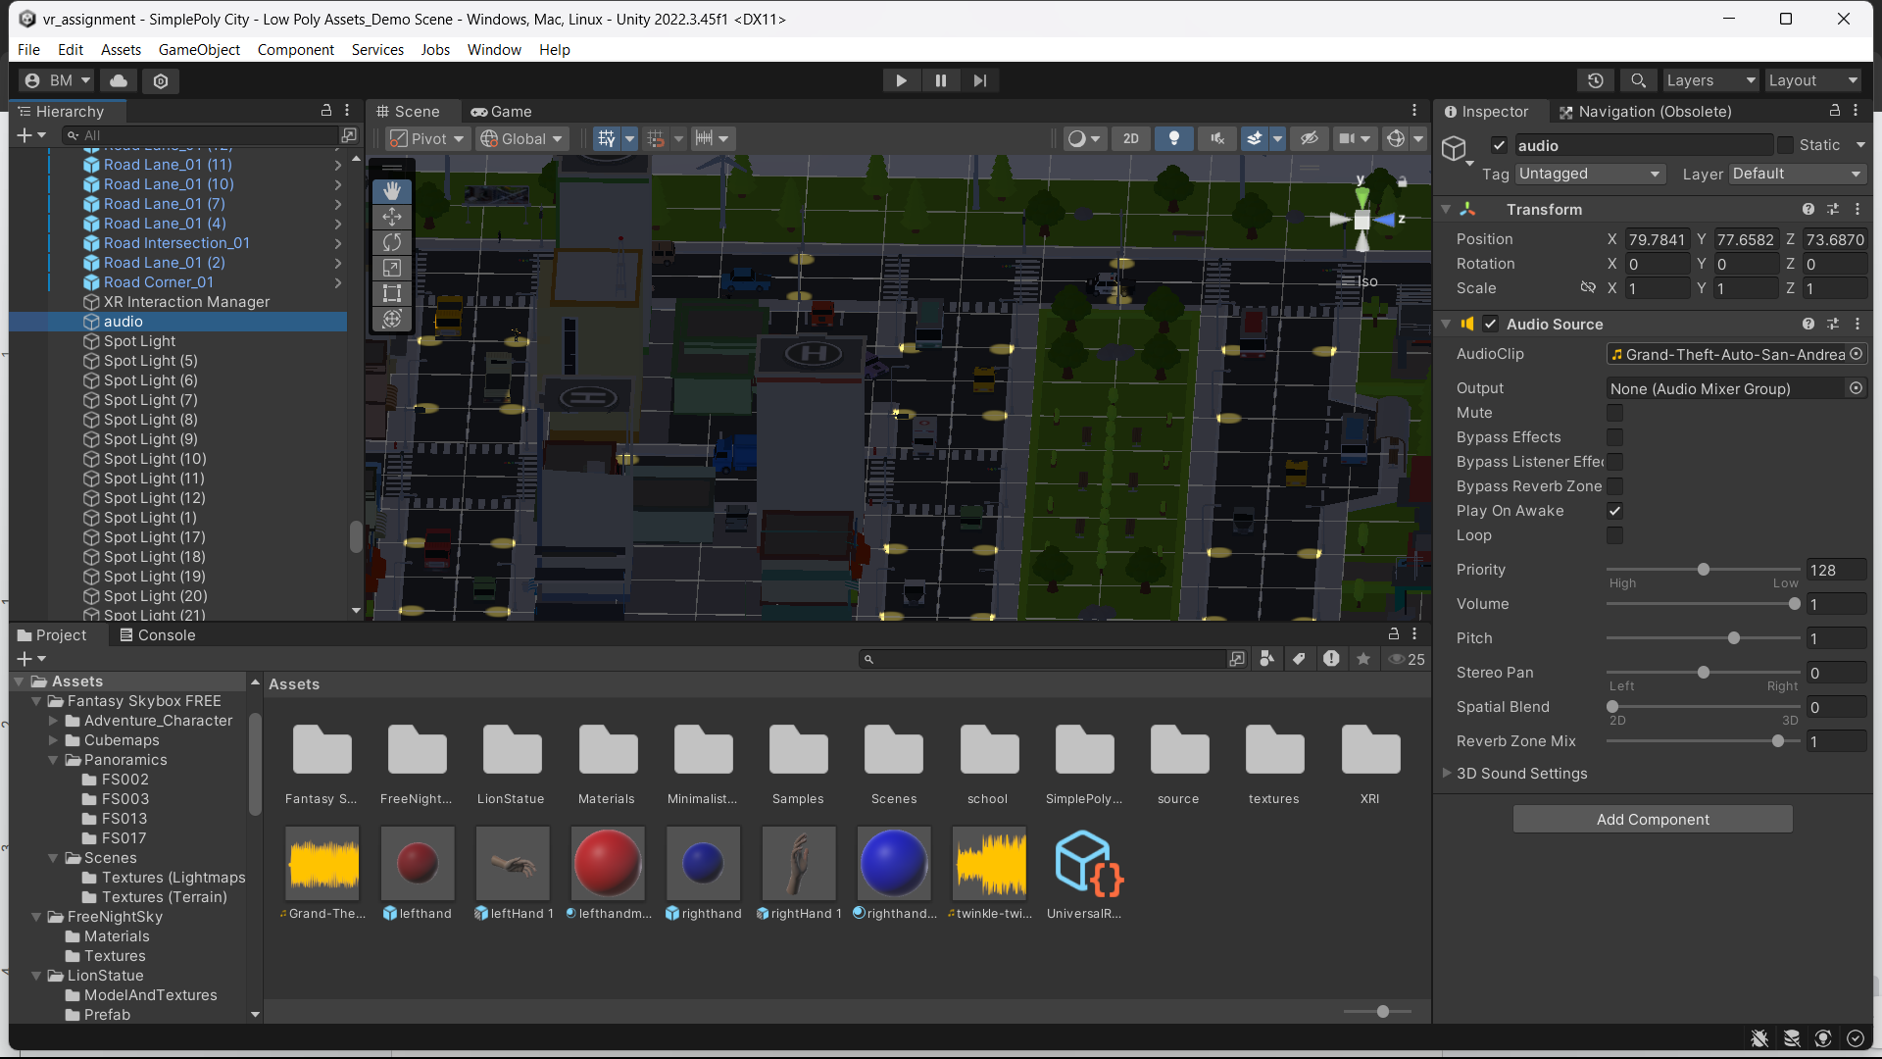

**Task 8: Implement Basic VR Interaction**

**• Create a Grabbable Object**

**• Add Grabbable and Grabber Components**

**Steps:**

1. Imported a red water spray tank which can be kept in the city to grab it.
2. Applied grabbable properties with colliders and rigidbody components for interaction.
3. Added Grab Interactable and Grabber components using the XR Interaction Toolkit.

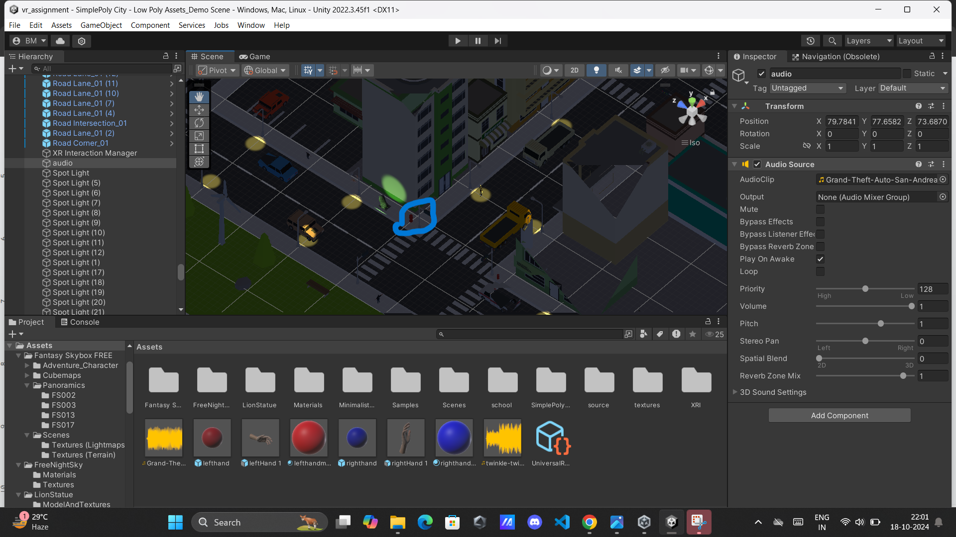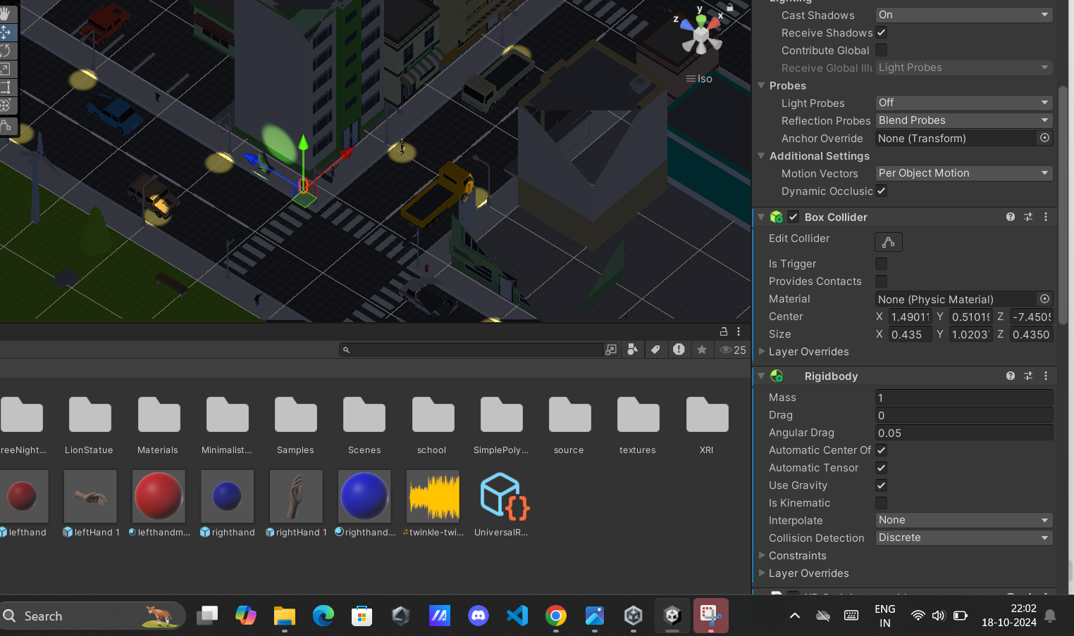

**Task 9: Write the VR Interaction Script**

**Steps:**

Code of movement using the **WASD, e,q** keys:

using UnityEngine;

public class PlayerMovement : MonoBehaviour

{

public float speed = 5f;

public float rotationSpeed = 700f;

private CharacterController controller;

void Start()

{

controller = GetComponent<CharacterController>();

}

void Update()

{

// Get input for movement

float moveHorizontal = Input.GetAxis("Horizontal"); // A and D keys

float moveVertical = Input.GetAxis("Vertical"); // W and S keys

// Create movement direction based on input

Vector3 moveDirection = new Vector3(moveHorizontal, 0, moveVertical);

moveDirection = transform.TransformDirection(moveDirection);

moveDirection *= speed * Time.deltaTime;

// Move the character using the Character Controller

controller.Move(moveDirection);

// Handle camera rotation with mouse

float rotateHorizontal = Input.GetAxis("Mouse X");

transform.Rotate(0, rotateHorizontal * rotationSpeed * Time.deltaTime, 0);

}

}

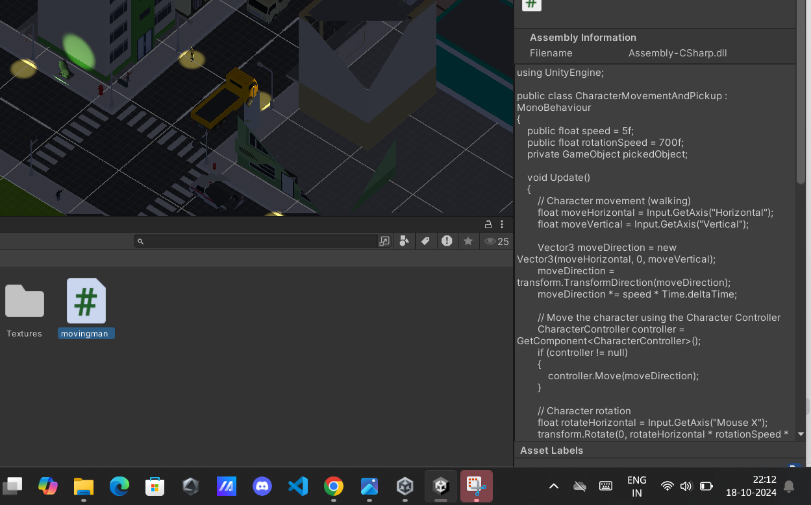

**Task 10: Demo application**